## 1. Title Page

When Robots Bleed

Created by Total Letdown Games

Date: 2/8/2023

For Pc on Steam

Age 13+

ESRB rating of teen +

Ship Date: **TBA**

## 2. Game Outline

#### **Game Story Summary:** “Test subject no. 0”, a robot with no name who awakens from its slumber one day to a dystopian future where humanity has died and robots remain. Equipped with no knowledge or recollection of its past, the only task it knows is to stop an entity known as (E#######). Alone, broken, and in a world rife with robots who seem to be targeting it, will the unnamed robot find and learn what exactly (E#######) is?

#### **Game Flow Outline:**

To destroy the threat causing robots to destroy each other and escape the factory. Explore the factory and make your way to the final area where the main threat is hidden. Each area holds a special keycard that progresses the game. After collecting 4 key cards, the final area is unlocked and you take on the final boss in order to save all bots.

## 

## 3. Character (Emanuel)

* Player: Play as a reactivated robot “Test subject no. 0” (player will have the option of choosing the name)
* The character is awakened in one of the lower floors of an old factory/ lab
* Character Abilities/ equipment:
  + Dash - horizontal
  + Double jump
  + Hover
  + Blast
  + Beam blade
* Robot part pickups:
  + Core(s) (each core you pick up upgrades the health)
  + Upgraded arm (gives you your blaster and/ or beam blade)
  + Upgraded legs (gives you the ability to double jump/ hover)
  + Thrusters (gives the ability to dash)

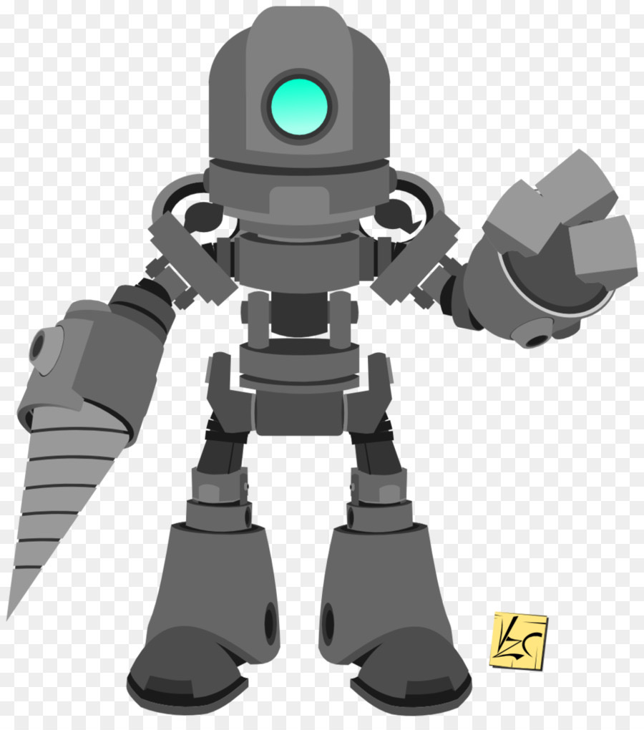

## 4. Gameplay (Joseph)

#### GamePlay

When Robots Bleed is a 2D platformer Metroidvania focused on being a horror game that will keep the player in very tense situations the game. You play as a robot who is broken down and in need of repairs exporting an old abandoned factory destroyed in this future dystopian world. Survived as you face off dangerous robotics enemies that are out to kill you and to find out your past and why you were motivated.

As you keep on exploring you will need to get special keycodes to unlock more of the factory. However, holding on to these keys puts a target on you and activates a unique enemy that hunts you down and you can not kill. Avoid them quickly as you need to get back to safe rooms and open up the next area to stop this unkillable enemy in its tracks.

You as the robot will also be able to gain new powers and abilities from around the factory. By

finding specific broken-down bots with parts on them and defeating bosses you can gain powers to kill off your enemies and to also move around the maps easier. Things like your beam having charge shot, double jumping, dashing, magnetic grabs, and more are in store for you to use.

The world of this destroyed and abandoned factory is split into different areas the player can explore. The layout of the levels is that of the Metroidvania games where it is one big world broken up into areas each with its environment, game mechanics, and even enemies.

The factory will have a starting area which is the entrance to the factory and the interworking machinery that is used to produce robots. The second part of the factory is the garden where an overgrowth plant and nature have taken apart this factory. Finlay the Labs a stang part of the factory that has a cold and chemicals all over the place laid out in experimental tubes that are emptied.

## 5. Game World (Simi)

### Environment

#### **A pixelated art style:**

* + Many of the game’s laboratory backgrounds and other artistic details depict decrepit walls and machinery—to emphasize how abandoned the laboratory is.

#### **Concept examples:**

* + Abandoned style

[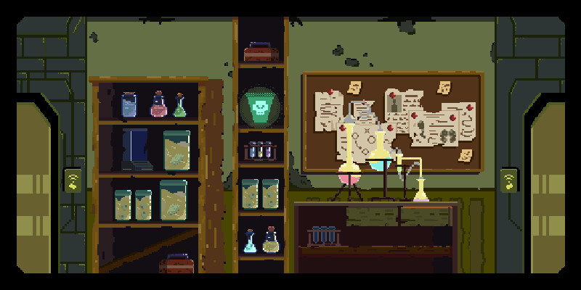](https://www.artstation.com/artwork/oAmVg4)

* + A high tech lab room style

[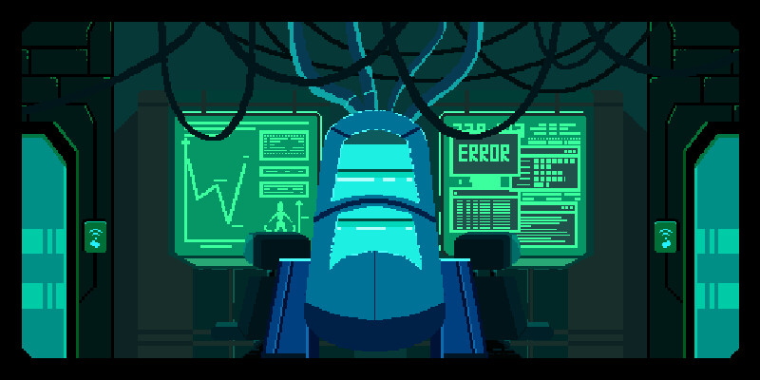](https://www.artstation.com/artwork/oAmVg4)

#### **Platform aspects:**

* + The platforms resemble and compliment that background and items found around the game. High-tech equipment, broken and deteriorated items.
  + Enemies such as monsters and robots are found on these platforms with the intent on killing the player.
  + The platforms also give the player access to powers and abilities to aid their gameplay and progress the story.

### Mood

#### **Athmosphere**

* + The platform stages range from different lighting including:
    - Light
    - Dark
    - Colored
  + Indicating a change in tone and the overall mood of the game.

### Music

#### **Screen Themes**

* + The title and credits screens have themes that play.

#### **Character Theme**

* + The main character the player controls has its own theme song that would play at the beginning of the game, at a pivotal story point, and at the end of the game

#### **Gameplay Themes**

* + Different areas of the game have their own theme song. The forest at the start of the game and different areas of the laboratory.

#### **Combat Themes**

* + Every boss has its own theme

#### **Storyline Themes**

* + Pivotal points to the story has its own theme song to enhance the mood of the situation.

### Diagram

#### **Diagram of layout**

* + Example of an area diagram

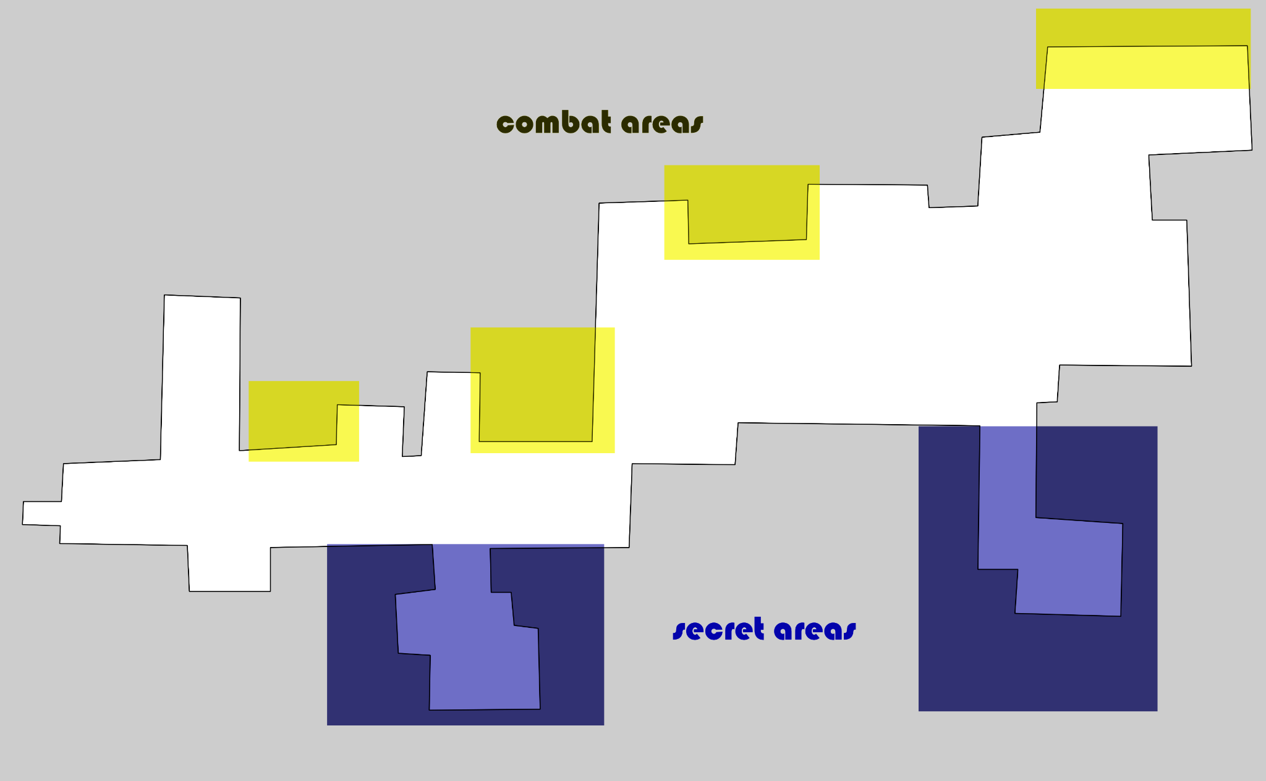

### Maps

#### **Example of platform layout**

* + Messy lab room

[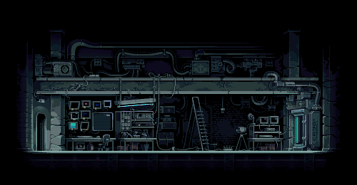](https://pixeljoint.com/pixelart/123196.htm)

## 6. Game Experience (Simi)

### Mood

#### **Screens**

* + The menu screen consists of playing the game, accessing save data, credits, and an options tab for controlling:
    - Sound
    - Music
    - Overall volume
  + When the player starts the game for the first time they will be brought to the beginning where the player wakes up in the forest.

### UX/UI

#### **Style**

* + The HUD and UI aspects that fit the sci-fi and robotic aesthetic

[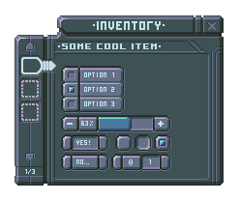](https://opengameart.org/content/sci-fi-user-interface-elements)[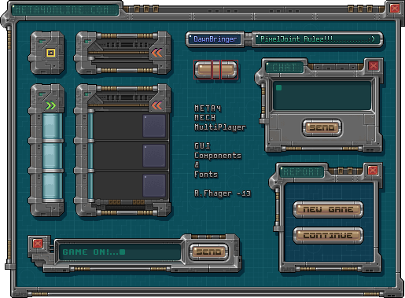](https://www.google.com/url?sa=i&url=https%3A%2F%2Fkeatsss.artstation.com%2Fprojects%2FGXBrkN&psig=AOvVaw16C70Ba10uJ8kpmo703NRA&ust=1675916419582000&source=images&cd=vfe&ved=0CBAQjhxqFwoTCIifjqiJhf0CFQAAAAAdAAAAABAQ)

### Sound

#### **SFX**

* + Footsteps for different areas of maps
  + Combat sounds from player
  + Combat sounds from enemies
  + Bosses have varied sounds for different attacks/phases/dialogue

## 7. Gameplay Mechanics (Emanuel)

Hazards: Throughout the game there will be a robot/ ai that will randomly appear on your quest. Alongside a variety of traps, obstacles, and more that you will need to avoid/ defeat along the way.

* Shock traps/ electric floor
* Molten metal/ lava
* bladed/ spike traps
* Bombs/ Seeker bombs
* Missiles
* Pitfalls
* lasers
* Etc.

Player gadgets/ abilities:

* Double jump/ thrust jump
* Dash
* Beam blade/ slash
* Blaster
* hover
* Magnetic hook
* Electric Run
* core(sj - upgrades character health (maybe more)
* Parts from rundown robots(which is going to be in different parts of the map)
  + Arms (which give you your blaster & beam blade
  + Legs (double jump/ hover)
  + Cores

Pickups(?):

* Gears
* Ammo
* Energy

## 

## 8. Experience JAOSN

### **COMMON ENEMIES**: The place is crawling with mechanical entities that are roaming around endlessly. Most of them have a very straight forward movement and attacks that can easily be reactable.

* **Walker:** Once a worker robot, but now it roams the area looking out for anything that is detected as “dangerous”. Shooting its rifle in three short bursts from afar and does a melee attack when the player is too close
* **Hunter:** Agile, and precise, the Hunter is eager to hunt and is able to pounce at the anyone in one and bleeds it’s foe
* **Golem:** This immobile mech may be slow, but it packs a puch with its strong arrms and tanky stats, dont get too close or you might just be in big trouble
* **Scout:** Soaring through the air, the scout is nothing but just pure fire power, focusing ending it’s target with precision aim with its front two turret guns.
* **Bomber:** As it’s names states, the Bomber is capable to use its shoulder mounted rocket launchers to dish out troumendious damage across the field.
* **Igniter:** With flamethowers attached to it’s arms, the Igniter is able to shoot out flames strong enough to melt through any opponent.

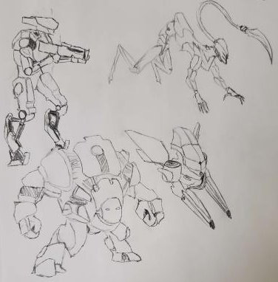

## 9. Multiplayer / Bonus Materials JASON

### **GAME MODES:** The main game will be in single player, but once the player finishes the first level/area, the player is able to unlock different types of modes, one of them being a speed run mode.

### **VERSUS MODE:** Versus mode, as the name suggests is a mode where players can complete an area that they have completed in the single player mode and race against other players that have also completed that level

* + When playing versus mode, you can challenge another players recorded run in a level and race against their “downloaded data” (shadow)

### **NO HIT MODE:** This mode is for players who have completed the entire game and can challenge themself by playing this mode. The mode forces you to be defeated in a single hit by any enemy

### **ASSIST MODE:** This mode allows you have to extra help in your endevours across the map, ranging from movement speed increase to more damage on weapons

### **BUILD MODE:** Every wanted to make your own levels? Well in this mode, you can make any map you want with the ingame build tool. After you finish your level, you can play and confirm your level and post it online and let other players to try your invention.

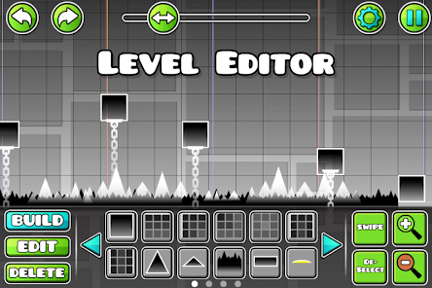

## 

## 

## 10. Monetization

* **INITIAL RELEASE:**
  + Players will be able to purchase the game on Steam for a one-time payment of $19.99. The game will launch with an introductory discount of 15% to encourage interested players to pick the game up early.
  + Players will be able to purchase and enjoy additional content on Steam, such as the complete soundtrack, for $9.99 at launch.
  + A bundle with the base game and the additional contents will also be offered for new players interested in both.
* **POST RELEASE**:
  + Players of **When Robots Bleed** will be able to continue their journey within the world with **paid DLC** content:
    - **Side-story DLC**:A new experience for players, this DLC offers a different perspective of the main story and allows players to explore and understand the world of **When Robots Bleed** more deeply. The DLC will provide new levels, locations, and story elements. Additional content for the base game may also be added.